Bahria University,

Karachi Campus



LAB EXPERIMENT NO.

**08**

LIST OF TASKS

|  |  |
| --- | --- |
| TASK NO. | OBJECTIVE |
| **1** | **Write a python program which can read any dataset and implement Neural Network** |
|  |  |

Submitted On:

**LAB 8 (NEURAL NETWORK)**

**TASK 1:** Write a python program which can read any dataset and implement Neural Network

**DATA SET 1 (CHURN MODELING)**

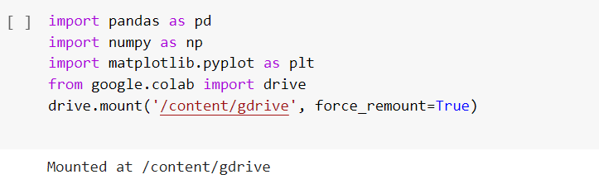

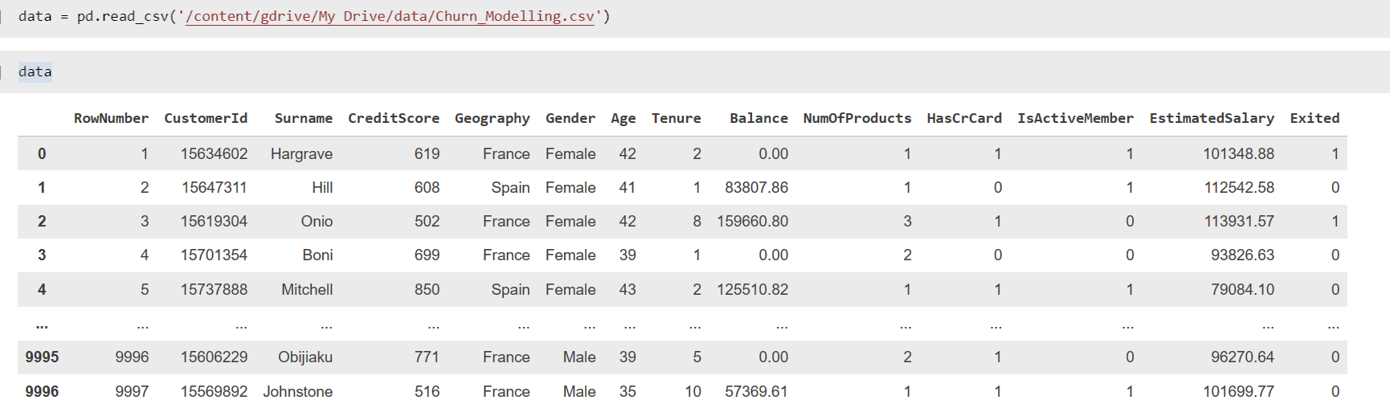

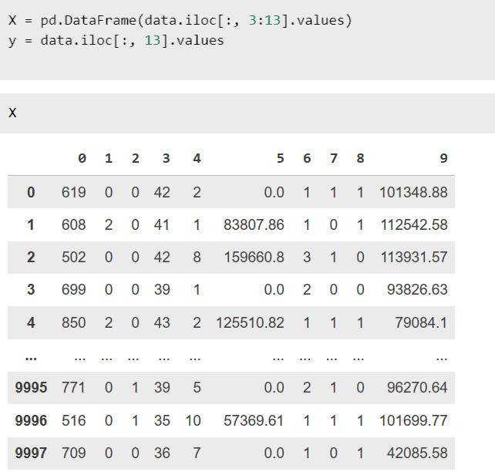

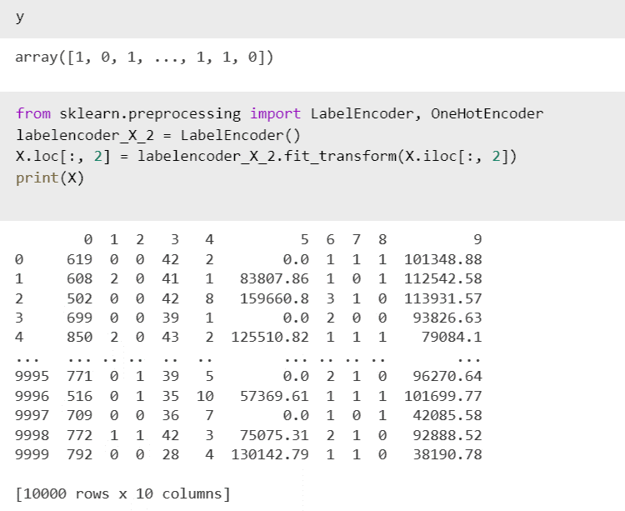

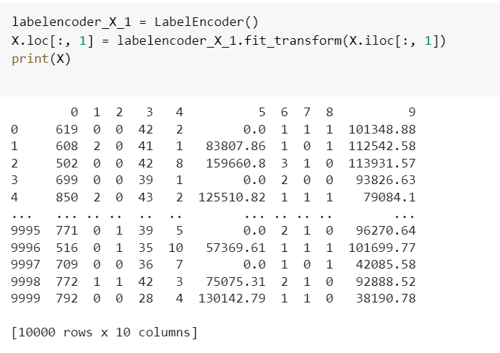

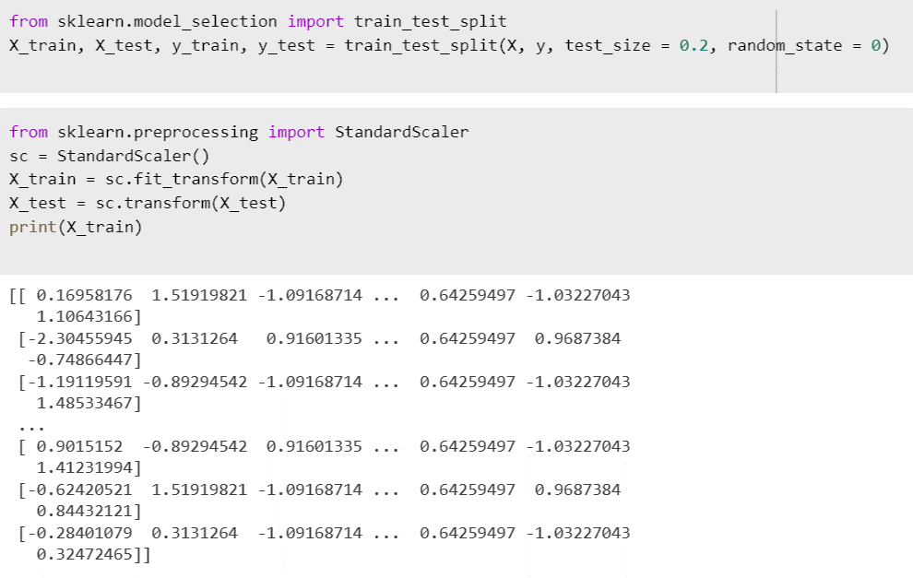

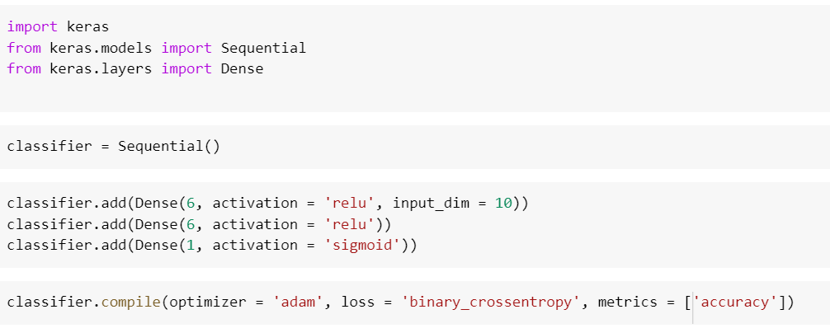

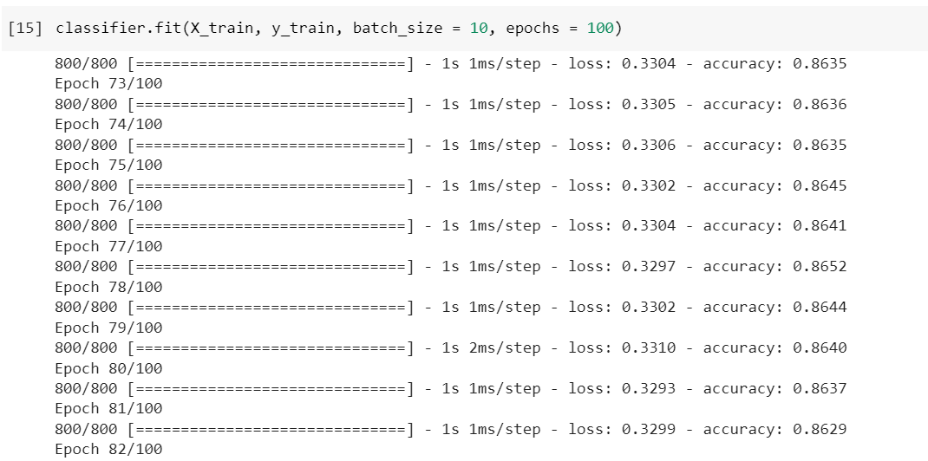

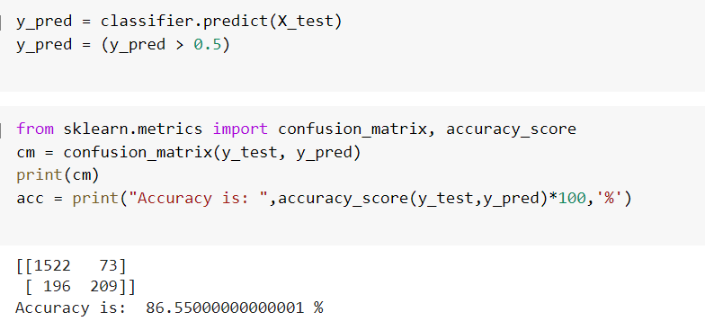

**DATA SET 2 (LIVE FACBOOK POST REVIEWS)**

